Southern Baptist
Disaster Relief
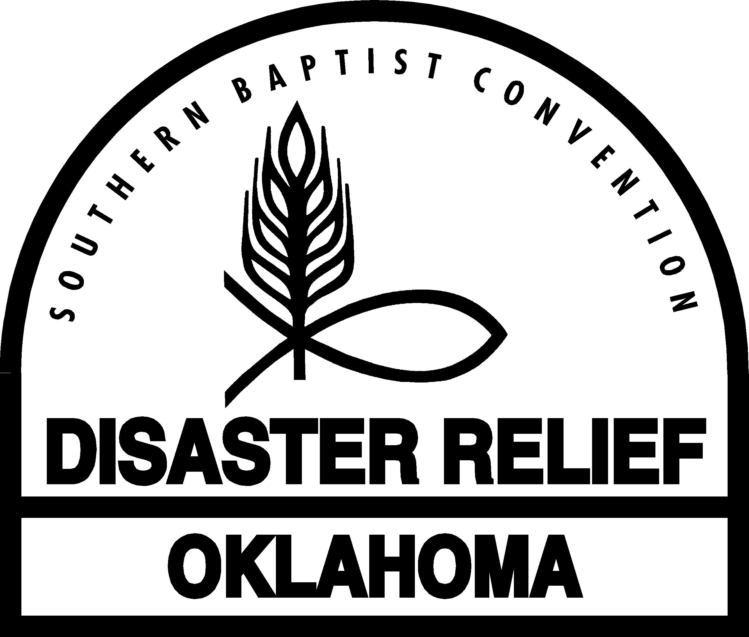
Family Preparedness
for Disaster

3/18/08
Table of Contents

Section One
The Family Disaster Plan 1
Developing a Family Disaster Plan 1
Shelter for Your Family 1
Training Your Family 2

Section Two
The Family Disaster Supply Kit 2
Developing Your Family Disaster Supply Kit 2
Storage of the Family Disaster Supply Kit 3
Practicing the Family Disaster Plan 3

Section Three
When a Disaster Strikes 4

Appendices
Appendix One: Family Disaster Plan Checklist 5
Appendix Two: Family Disaster Supply Kit Checklist 6

Family Preparedness for Disaster

Goal: to help families learn about the disaster hazards in their community and develop a plan to survive after a disaster event as well as to minister to others.

Today more people live in disaster prone areas. It may take a few hours or a few days for help to reach your family. Therefore, it is important for you to prepare your family to survive in the event a disaster affects your community. Families are encouraged to develop a plan and assemble a supply kit to insure survival until assistance arrives.

This manual is divided into four basic sections:

- The Family Disaster Plan
- The Family Disaster Supply Kit
- When a Disaster Strikes
- Checklists: The Family Disaster Plan and the Family Disaster Supply Kit

The Family Disaster Plan

Developing a Family Disaster Plan

The first step in developing a family disaster plan is to identify the disaster hazards that may affect your community. Examples are chemical spills, earthquakes, fires, floods, hurricanes, power failure, terrorist attacks, tornadoes, transportation accidents, snow/ice, etc. Take time to educate your family about the disasters that can happen in your community or to your family. The purpose is not to frighten family members but to help them identify the possibilities and develop an appropriate response.

After identifying the disaster hazards, determine the needs of your family in case such an event occurs. A list should be created “by” your family “for” your family so any special needs and desires of your family can be considered. This list should cover what it would take to survive for three days in the event of a disaster. Give time to writing the family disaster plan on paper so no one will forget.

Shelter for the Family

Careful consideration must be given to sheltering the family during crisis. This decision will depend on the size and nature of the crisis. Is your home damaged? To what extent? Do you need to evacuate the neighborhood? Can you travel outside of the area? Do you have utilities?

Other options for your family are public shelters sponsored by the American Red Cross or your church. Be prepared to take clothes, medications, blankets, sleeping bags, and items to entertain family members.

Should you need to evacuate the area, use routes that have been identified in your disaster plan. Know the predetermined place your family should evacuate to.

If your family owns a camper or tent, you can use them to shelter your family until evacuation is possible or until outside help arrives. If necessary, your family can use a van or automobile for shelter until better accommodations are available. Do not run the engine or radio in the vehicle. The dangers of causing the battery to die or carbon monoxide poisoning are too great to allow the vehicle to run with your family inside.

Training Your Family

Training is an important part of your family disaster plan. Training gives family members confidence and experience. The stress of a disaster situation is not the time to try to figure out how to do something or use a piece of equipment from your family disaster supply kit. The non-threatening atmosphere of pre-event training is a better time for familiarizing your family with your disaster plan and equipment.

Take time to discuss your family disaster plan and supply kit. Seek opportunities to have your family trained in disaster relief by your state Baptist convention disaster relief director.

The American Red Cross also provides training in the following areas: disaster services, first aid, cardiopulmonary resuscitation (CPR), mass care, and sheltering.

Many local, city, county, and state emergency management agencies provide training for disasters common to their area. Educating your family about emergency management services at all these levels will help them understand the role of the various agencies during times of disaster.
Your family disaster plan training should also include how to use the equipment in your family disaster supply kit. How to place batteries in a radio or flashlight and how to light a lantern, candles, or camp stove safely are examples of what should be covered during a training time.

Planning for a rendezvous site for your family in the event of an emergency should also be part of your family’s disaster plan. If your family had to evacuate your home during an emergency, where would you meet? Meeting in a neighbor’s yard or on the street corner could save the lives of family members.

In the event your neighborhood is destroyed or restricted, where would your family meet? A local store, church, or friend’s home could become a rendezvous site outside your neighborhood. Your family should know where to rendezvous outside your neighborhood.

Your family should identify an out-of-state contact person. A family member or friend identified as a contact person may become the one person who can provide information on the whereabouts and status of family members, especially if you become separated.

The Family Disaster Supply Kit

Developing Your Family Disaster Supply Kit

Make a list of those items your family will need to survive three days in the event of a disaster.

- Water
One gallon of water per day per person. Special needs should be considered and additional water supply may need to be placed in your family disaster supply kit.

- Canned and packaged food
Canned meat, fruit, vegetables, juice, soup, and milk; high energy and granola bars; peanut butter; jelly; crackers; trail mix.

- Comfort food
Cookies, hard candy, sweetened cereals, lollipops, instant coffee, and tea bags.

- First aid kit.
If a family member takes a maintenance prescription, a three-day supply of this drug should be included.

- Equipment and tools
Eating utensils—forks, spoons, knives, hand-operated can opener, matches, signal flares, fire extinguisher (ABC), a battery-operated radio and flashlight with extra batteries, a camp stove or some other device to heat food, pliers, wrenches, tape, rope, plastic sheets, sewing kit, a tent, toilet paper, towelettes, personal hygiene items, plastic bags, a plastic bucket with lid, chlorine bleach and disinfectant, paper, pencils, whistle, compass, and a map of your community

- Clothing and bedding.
Sturdy shoes, work boots, rain gear, hats, gloves, blankets, sleeping bags, thermal underwear, and coats.

- Special items
Baby items, eyeglasses, contact lenses, copies of important family documents, entertainment items (games, books), cash, etc.

Storage of the Family Disaster Supply Kit

Care should be taken to provide adequate and safe storage. Keep your disaster supply kit in a dry, cool place. The kit should be covered to protect the supplies and foods from being damaged.

Be sure to periodically inspect the items in your disaster supply kit for spoilage and expiration dates. One suggestion is to do this with the time change each spring and fall. Change the batteries in your smoke detector and replace food in your disaster supply kit as needed.

Practicing the Family Disaster Plan

Invest time in practicing the family disaster plan with each family member. Eveyone should be familiar with all components of the family plan. How to use the tools and equipment, where the kit is stored, how to retrieve the kit, how to prepare the food, what to do if separated from other family members are all important lessons to learn.

When a Disaster Strikes

- Stay calm. Keep your family members calm.
- Institute your family disaster plan.
- Inspect your house. Turn off utilities that are damaged and those you suspect are damaged.
- Help others in your neighborhood. They may need first aid.
- Begin immediately to seek information. The local television and radio stations that are part of the emergency broadcast system will be back on the air as soon as possible.
- Look for the local police, fire, and emergency management agencies to begin moving through the area to do damage assessment and respond to emergency calls. Provide information about your family and neighborhood to these local government officials. Share with them needs or concerns but be prepared for them to handle life-threatening emergencies first.
- Once you have determined that you and your family are safe, seek opportunities to minister to your neighbors and share your faith with those around you. You can provide hope. Hope in Crisis is an excellent witnessing booklet that can be used during disasters.

Conclusion

No one knows when a disaster will strike. However, we can and should be prepared in the event one happens. This course has given you practical suggestions and two checklists on preparing your family to survive in a disaster.

May God bless you and your family.
Appendix One
Family Disaster Plan Checklist

- Develop a list of disaster hazards for your community.
- Develop a list of the supplies your family will need in the event of a disaster.
- Develop a list of training needed by your family.
- Select your out-of-area contact person.
- Practice your family disaster plan.
- Locate the cut-off for the utilities for your home.
___ Gas ___ Electricity ___ Water ___ Phone ___ Cable
- Assemble the family disaster supply kit.
- Select a cool dry place to store the disaster supply kit.
- Identify the official community shelter nearest your family.
- Develop a list of telephone numbers you would need in a disaster.
- Identify the neighbors your family should check on in a disaster.
Appendix Two
Family Disaster Supply Kit Checklist

Water
- One gallon per person per day

Food
- Canned Fruit
- Canned Juice
- Canned Meat
- Canned Milk
- Canned Vegetables
- Cereal
- Crackers
- Energy Bars
- Hard Candy
- Instant Coffee
- Instant Tea
- Jelly
- Peanut Butter
- Salt/Pepper
- Sugar
- Trail Mix
- _______________

Health Items
- Antacid
- Anti-diarrhea Medication
- First Aid Kit
- Maintenance Drugs
- Medication
- Pain Relievers
- Paper Towels
- Personal Hygiene Items
- Plastic Bags
- Plastic Bucket and Lid
- Toilet Paper
- Towelettes
- ______________
Tools and Equipment
- Candles
- Chlorine Bleach
- Compass/GPS
- Disinfectant
- Eating Utensils (Knives/Forks/Spoons)
- Fire Extinguisher
- Flashlight and Batteries
- Hammer
- Hand Can Opener
- Map
- Matches/Lighter
- Plates/Cups/Bowls
- Pliers
- Screwdriver
- Shovel
- Pots and Pans
- Radio and Batteries
- Rope
- Sewing Kit
- Signal Flare
- Soap (Dish and Hand)
- Tape
- Tarp/Plastic Sheets
- Tent
- Whistle
- Camp stove
- Wrench
- _________________

Special Items
- Games/Books
- Paper
- Pencils/Pens
- Phone Numbers
__ Family Documents
- Shelter Location

Clothing and Bedding
- Blankets
- Sleeping Bags
- Change of Clothes
- Coats
- Gloves
- Hat
- Rain Gear
- Shoes/Boots
- ____________

Automobile
- Emergency Kit
- Flashlight
- Tools
- ________________

Baby Items
- Baby Clothes
- Baby Food
- Baby Toys
- Diapers
- Formula
- Plastic Bottles and Bags

Special Items
- Eye Glasses
- Contact Lens and Solution
- _________________
- _________________

Other Needs
- _________________
- _________________
- _________________

